Capping machines have a lot of components but the two most key to consistent on and off torques are the chucks and clutches.
Chucks must grip the cap positively without slipping and the clutch must slip or release cleanly when the proper on torque is achieved.
Clutches are mechanical devices designed to slip or release when torque reaches the target set point. In this discussion, we will take a bit broader view and include other devices that are used to control the capper application torque.
Mechanical, friction or plate style clutches consist of 1 or more plates that are pushed together with springs. One plate is attached to the drive motor or shaft, the other to the chuck. Increasing the spring pressure increases the amount of friction between the plates and the torque before they begin slipping. A single pair of plates provides a relatively small surface area and requires considerable spring pressure for anything more than minimal torque. Most capping machines use multi-plate clutches. These consist of an interleaved stack of metal and fiber plates. The fiber plates are connected to the chuck and the metal plates to the drive (or vice versa). The increased surface area requires less spring pressure and makes fine torque adjustment easier.

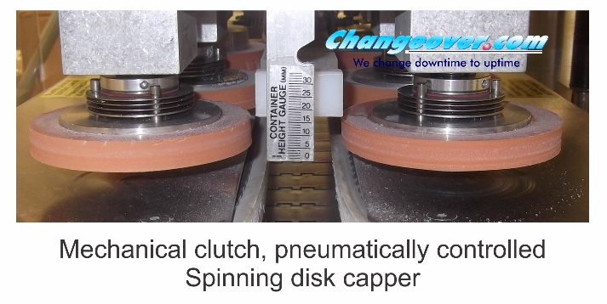
Clutch pressure can be controlled by tightening or losing a nut or screw to increase or decrease spring tension as shown below:
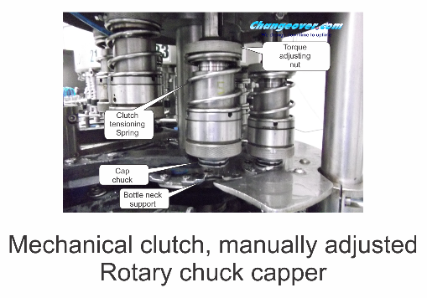
Spring loaded clutches are simple and reliable but have two major drawbacks:
- They cannot be adjusted while the machine is running.
- It is difficult to set the clutch values quantitatively. Generally, clutch pressure must be set by trial and error.
Pneumatic clutches use air pressure instead of a spring to force the plates together. This allows clutch pressure to be adjusted via an air regulator on the fly with the machine running. It also allows a quantitative set point, the air pressure, which makes for more precise setups.
Mechanical clutches are reasonably consistent but if they get wet or oily, they will slip more easily so that the normal air or spring pressure will not be sufficient. Since they are designed to slip, they will wear and need to be replaced periodically. Replacement periods will vary depending on application and clutch design.
Mechanical clutches slip rather than releasing. This causes them to continue applying some torque even after they begin slipping. Magnetic clutches, on reaching target set point release cleanly and apply no additional torque.
There are several styles of magnetic clutches but all rely on the strength of attraction between magnets. This attraction diminishes rapidly with distance. One style consists of two concentric magnets. The outer, female, magnet is driven by the capper. The inner, male, magnet drives the chuck. The breakaway force is a function of how much overlap there is between the two. Since this is a measurable distance, a scale on the side of the clutch showing the amount of overlap can be used to precisely set the torque at each setup.
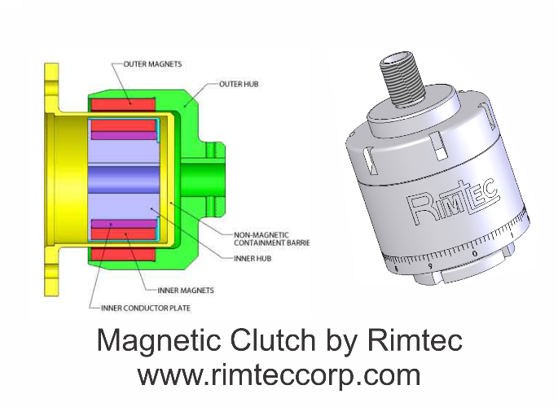
Since there is no contact between the male and female magnet, there are no wear parts.
The magnetic attraction between the two magnets keeps them coupled until the correct torque is reached. When the set point is reached, it overcomes the magnetic attraction and the two halves spin freely. They cannot recouple under load but recouple readily once the cap has been released.
Air and servo motors eliminate the need for chucks altogether, driving the chuck directly.
Air motors are driven by compressed air controlled by a pressure regulator and needle valve for flow. The speed and torque of the air motor is directly related to the air pressure. When the correct cap torque is reached, the motor will stall. This allows application torque to be set by regulating the air pressure. Reduced pressure will give less torque but it will also slow the speed of the motor. Depending on the machine, this may increase the cycle time.
Servo motors are precisely controllable electrical motors. Maximum torque is a function of electrical current and the motor will stall when this torque is reached. Speed, acceleration/ deceleration, stalling torque can all be adjusted electronically. Setup parameters can be stored in memory and recalled for fast, precise setup every time.

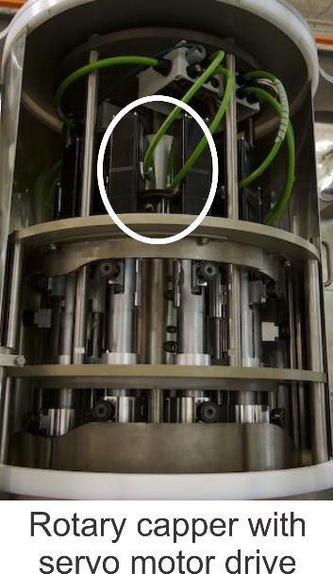
Servo motors can also perform some basic quality checks. If a cap requires too much or too little torque to turn it down, the servomotor control will detect these abnormal conditions and reject that bottle and cap. Servomotors, by measuring the motor current, can determine precisely how much torque was applied to each cap. This can be recorded and used for Statistical Process Control (SPC) analysis of each capping head and/or the capping machine overall. The main disadvantage to servomotors is that they can be costly, though prices have been coming down steadily. They can also be complex to install in a rotary capper due to the need for a rotary interface for power and controls.

Chucks
Clutches serve no purpose unless their output can be transferred to the cap. The term “chuck” is used to refer to a female component that fits over the cap and grips it tightly, allowing it to be turned down to a pre-set torque. It is critical that the chuck not slip on the cap. If it does, cap application torque will be determined uncontrollable slippage between chuck and cap and not by the controllable clutch. If the chuck slips on the cap, it will cause excessive wear to the chuck. In some cases such as a shell and insert chuck , it will generate rubber shreds on the product that may become trapped under the label resulting in a lumpy appearance.
The simplest chuck style is the shell and insert. This consists of a metal, normally aluminum, shell with a rubber or other elastomeric insert. The insert has a conical recess.

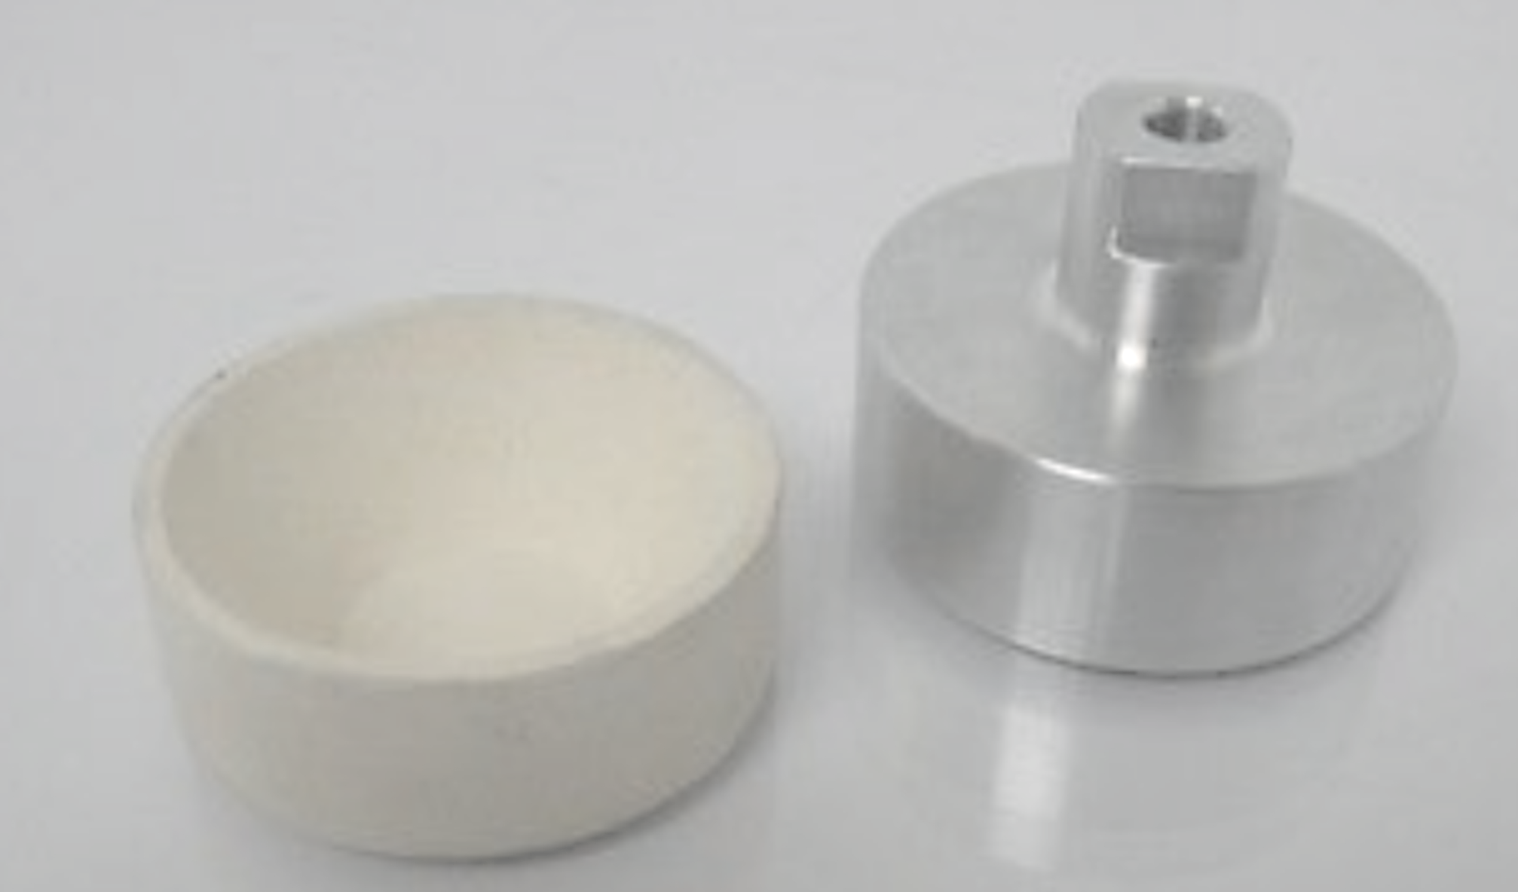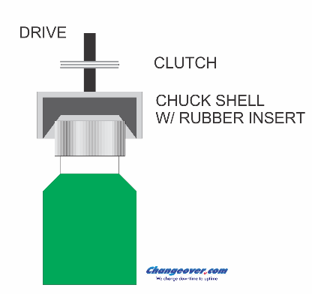

The chuck is pressed down on the cap and the insert grips the upper corner of the cap as shown below. Due to the limited contact area, considerable downforce may be required to prevent the chuck from slipping on the cap. This downforce may collapse or distort the bottle exacerbating slippage. When the chuck slips on the cap, especially with a serrated cap, rubber shreds are generated and/or the cap is scuffed.
The upside to these chucks is that they are simple and inexpensive with no moving parts. One insert can handle a range of cap sizes eliminating the need for chuck changeover in some cases.
Serrated chucks are sometimes used but will only work if the cap has matching serrations to provide a mechanical grip. The chuck picks the cap from a staging button and it is held in the chuck by detent balls. The matching chuck and cap serrations provide a positive grip to eliminate slipping.
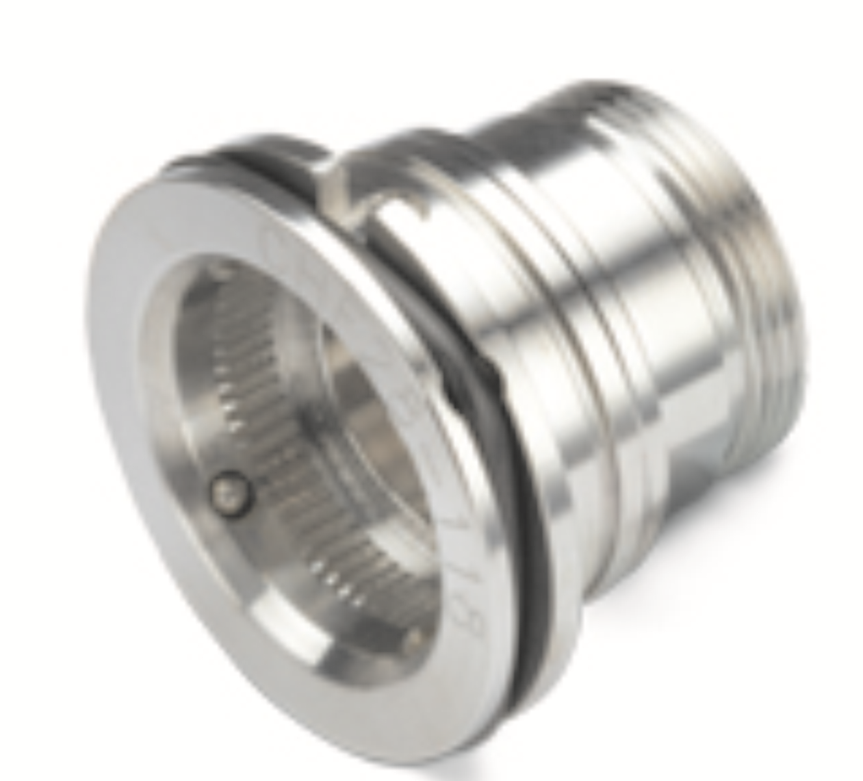

Another type of passive chuck is this segmented chuck. The outer shell has 3 L-shaped semi-circular segments mounted on pins so that they can pivot. The chuck spins continually. When empty, centrifugal force forces the segments out and open.
As the chuck comes down over the cap, the horizontal legs are pushed up, causing the vertical segments to grip sides of the cap. Matching serrations or an elastomeric liner, make for a positive grip with little chance for slippage.
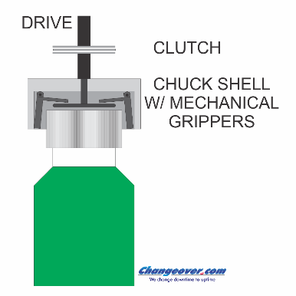
Higher speeds and more difficult caps may require more positive, actuated, gripping. Pneumatic chucks incorporate a rubber donut and an air channel in the shell.
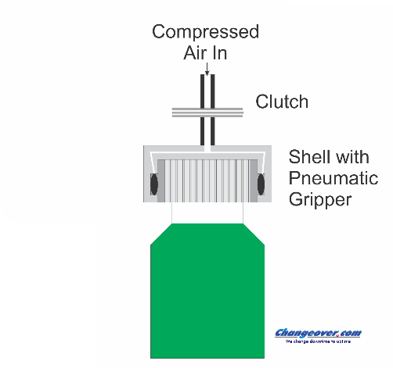
When the chuck is empty, no air pressure is applied the donut is in its open position. This allows the chuck to come down easily over the cap. Once over the cap, the chuck is pressurized. This forces the donut in to gripping the cap. After tightening, the air pressure is relieved and the donut expands back to the open position allowing the chuck to be lifted from the cap.
Still another style of chuck eliminates the need for a clutch. These chucks have 3 gripping segments which begin the capping cycle the retracted, open, position as shown below.
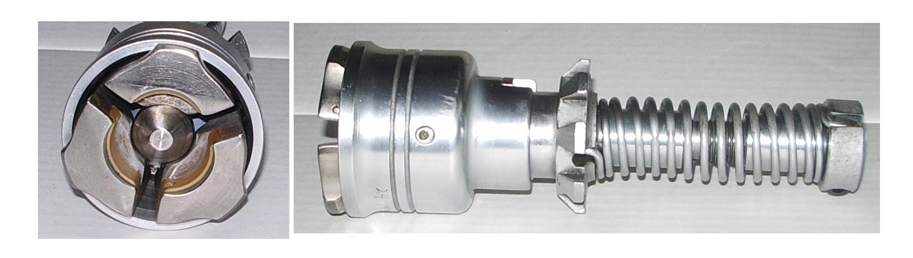
As the chuck comes down over the cap, the cap pushes the center pin up, releasing the segments which snap closed under spring pressure. The chuck spins the cap down and as it does, loads the spring. When desired torque is reached, the segments snap opening. This allows the chuck to continue spinning but, since it is no longer gripping it, does not apply any further torque to the cap.

